**Lab: Understanding Forest Succession**

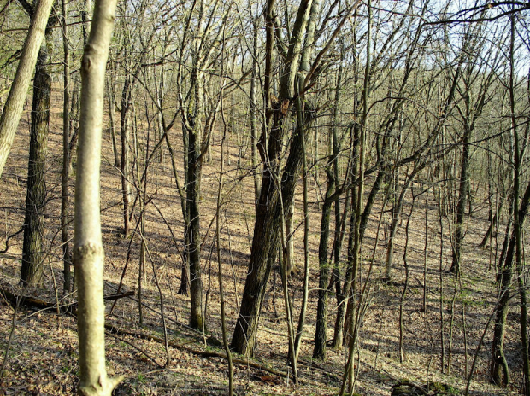The goal of this lab is to introduce students to the concepts and assumptions underlying succession and life history attributes. Life history attributes are those key characteristics the define a tree species’ niche.

Students will utilize the Site Vegetation Calculator, a utility developed by US Forest Service that simulates vegetation dynamics using a few simple rules and algorithms within a single forest stand. The Site Veg Calculator follows the assumptions from the LANDIS-II simulation model, but is very simplified and only considers a single site without disturbance or spatial interactions. It is **not** the LANDIS-II model. The Site Vegetation Calculator uses three suites of assumptions. Each suite of assumptions simulates succession in a slightly different way. Students will only focus on the most basic set of assumptions.

**Learning Objectives**: Succession occurs over many decades or even centuries, making it difficult for us to perceive change in the short-term. Scientists typically use models to represent and ‘accelerate’ their understanding of forest succession. The objective of this lab is for students to gain a better understanding of how succession operates and how succession is represented in computer models. Specifically, students should:

* Gain a better understanding of how species interact at the scale of a forested stand;
* Gain experience with how life history attributes influence successional dynamics;
* Gain experience using a small graphical tool to simulate successional change.

**General Instructions**

For the lab, we will focus on a small suite of life history attributes: shade tolerance, age of maturity, age of longevity. As we have discussed in class, these life history attributes are often correlated. A tree species with high shade tolerance typically has a long life span and is slow to mature.

There is another key parameter: the probability of establishment (PEST). PEST is the probability that a tree or cohort of trees will survive to maturity and it reflects the abiotic conditions (soil moisture, temperature, etc.). In a forest, this is highly dependent upon annual weather patterns, soils, seed size, browsing, etc. PEST does **not** reflect the light conditions, which are calculated separately.

For the lab, simply note that if PEST = 1.0, a tree species can always establish, *if there’s sufficient light*. If PEST = 0.0, a tree species can *never* establish. If PEST is > 0.0 and < 1.0, the model will stochastically decide whether a species is established by ‘rolling the dice’; it has a random number generator. Higher PEST has higher probability of becoming established.

Students should formulate three or four hypotheses about life history attributes and test them using the model. The hypotheses should address *general scientific questions* about succession although constrained by the available model. Formulate your hypotheses based on the successional changes you expect given the trade-offs among life history attributes. For example, you might hypothesize that if a shade tolerant species is present, eventually it will always dominate the forest. Next, determine how you will test your hypothesis using the model. It is OK if you fail to support your hypothesis! A good hypothesis should have some chance of failing - otherwise why bother doing the research!

First play with model using the book chapter attached to become familiar with its operation. You do not need to answer the questions supplied. Also be sure to quickly review the user manual for the tool.

Note: Don’t worry too much about actual tree species. If you know your favorite tree species well enough to use as an example, use it. Otherwise, think of your modeled tree species more as experimental units. You are the designer and you can create combinations of attributes not found in nature.

Finally, the attached book chapter has specific questions. You do not need to answer these questions but rather use them as a guide to learning the model. Your own hypotheses and tests and results are much more important.

**Detailed Instructions**:

* The lab will be supplied as a ZIP file on D2L.
* Download the ZIP onto a PC (Mac will not work).
* Open the zip. Notice the PDF of this lab plus many text files, e.g., Spp2Good.txt. The text files are ‘canned’ input files.
* Also notice the ZIP file (LANDIS-II-Site_v2.3.1) inside the first ZIP file. This contains the necessary program (i.e., executable): LANDIS-II-Site_v2.3.1.exe. Double-click this program to launch the Site Calculator.
* Finally, notice that inside the inner ZIP file is a User Guide for the Site Calculator.

**Lab Format**

The general form of the laboratory report will be as follows (*see Simply Guide to Lab Reports*):

* Always include **your name** and the **course name** at the top.
* Introduction (~ **300 words**): Describe the broader context and the overall objectives of the laboratory and the questions/hypotheses being explored. Explain why you chose your hypotheses. Example hypotheses:
  + *Succession will be less predictable as you add more species because...*
  + *Shade tolerance is the most important life history attribute for predicting succession.*
  + *Forest dynamics are generally unpredictable when the probability of establishment for all species is less than 0.5.*
* Methods (**> 100 words**): Describe what was done, how the experiments were designed and implemented, how the results were analyzed. Treat the lab as an experiment.
* Results (**~ 300 words**): The text should fully describe the findings and should ‘walk’ the reader through the graphs and table, highlighting what is pertinent and interesting. Include figures and tables that document findings. **Note:** Always reference graphs parenthetically, e.g., ‘*Carbon, however, appears to be unresponsive to utilization (Figure 9)*’.
* Discussion/Conclusions (**> 300 words**): Interpret the reasonableness of the results, the possible general relationships explaining the results, and the possible application of the results. Summarize implications and provide some broader context. For example, you might:
  + *Explain what we can learn from the hypotheses tested.*
  + *Explain the dynamics you observe based on your understanding of succession and life history attributes.*
  + *Describe whether the observed variation support Gleason or Clements’ view of succession.*
  + *Etc.*
  + **Do not stray too far from your hypotheses!** The Discussion should not be a miniature literature review.
* Literature cited if appropriate.
* Tables and Figures. **Include any graphics you find useful for interpretation** (right-click a graph, and select the “save image as” option). Tables and figures need to be clearly labeled (with caption) and units presented on both axes.

**Rubric**

Each section of the lab report (Intro, Methods, Results, Discussion, Figures) is worth up to 3 pts. The total number of points will be divided by 3 to arrive at your grade (up to 10 percent total).

1 pt. Minimal effort: Obvious mistakes in the analysis, poorly written, superficial conclusions, spelling and grammatical mistakes.

2 pts. Adequate: Analysis is correct and the conclusions are sound. Well written with no spelling or grammatical mistakes.

3 pts. Excellent: Analysis is carefully presented and integrates information from lectures and the readings. Clear and concise writing that is free of errors.